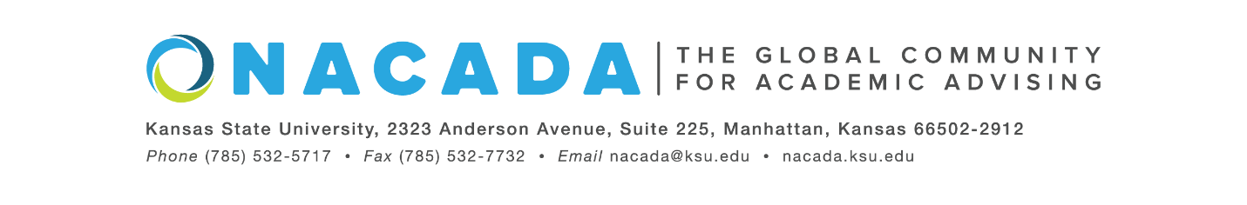
NACADA: The Global Community for Academic Advising
[INSERT DATE]
For Immediate Release
[For more information about the Global Awards Program for Academic Advising, visit https://www.nacada.ksu.edu/Programs/Awards/Global-Awards.aspx]

Or Contact: Lizbeth Alcantara, NACADA: The Global Community for Academic Advising
nawards@ksu.edu
[INSERT NAME] of [INSERT INSTITUTION], is a 2022 NACADA Student Research Award recipient from NACADA: The Global Community for Academic Advising as part of the 2022 Global Awards Program for Academic Advising. The Student Research Awards are presented annually to recognize research conducted during a Master’s, Ed.D., or Ph.D. program that significantly adds to the body of knowledge on academic advising. Each recipient receives $500, in addition to a commemorative plaque.
[INSERT NOMINATION DETAILS and TITLE OF RESEARCH AWARDED -Doctoral Thesis info]
Since 1983, NACADA has honored individuals and institutions making significant contributions to the improvement of academic advising. The mission of NACADA is to promote quality academic advising and professional development of its membership to enhance the educational development of students. NACADA’s membership has grown to over 14,000 faculty, professional advisors, administrators, counselors, and others in academic and student affairs staff concerned with the intellectual, personal, and vocational needs of students. The organization acts as the representative and advocate of academic advising, and those providing that service, to higher education.
[INSERT NAME] will be honored and presented with this scholarship in Portland, Oregon during the NACADA Annual Conference in fall of 2022.
----end----

